

**SESSION** **: 2:2021/2022**

**DEPARTMENT** **: JTMK**

**ASSESSMENT** **: LABORATORY TASK 2**



**CODE COURSE: DFP 30243**

**COURSE NAME: OBJECT ORIENTED PROGRAMMING**



NAME & REG. NO. : 1) KHAIRUNNISA ISMA BINTI AB MAJIT

32DDT20F2003

2) BUNGA SYAZWANIE BT MD TARMIZIE

32DDT20F2005

3) MUHAMMAD AFIQ MUHAIMIN BIN MOHD ZAINI

32DDT20F2029

PROGRAMME : DDT3A

LECTURER : HAZLEENA BINTI OSMAN/ RODZIAH BINTI IBRAHIM

INSTRUCTIONS :

1. Answer **ALL** the questions.
2. Submission Date : ……………………………………………………

|  |  |  |  |  |
| --- | --- | --- | --- | --- |
|  | | | | |
| **CODE / COURSE** | **DFP 30243 –** **OBJECT ORIENTED PROGRAMMING** | **LABORATORY TASK** | **~~1~~ / 2 / ~~3 / 4~~** | |
| **PROGRAM / CLASS** | **DDT3A** | **DURATION** | **120 MINUTES** | |
| **STUDENT’S NAME** | **KHAIRUNNISA ISMA BINTI AB MAJIT**  **BUNGA SYAZWANIE BT MD TARMIZIE**  **MUHAMMAD AFIQ MUHAIMIN BIN MOHD ZAINI** | **CLO** | **1P** |  |
| **REG. NO.** | **32DDT20F2003**  **32DDT20F2005**  **32DDT20F2029** | **TOTAL MARKS** | **/10** | |
| **LECTURER’S NAME** | **HAZLEENA BINTI OSMAN/ RODZIAH BINTI IBRAHIM** |

**CLO1:** Construct Object Oriented Programming concept and exception handling in Java programming (P4, PLO3)

**Learning outcomes:**

Upon completion of this lab, students should be able to:

1. Build objects in Java Program
2. Construct String in Java programs

**INSTRUCTION: Answer all questions.**

**QUESTION 1**

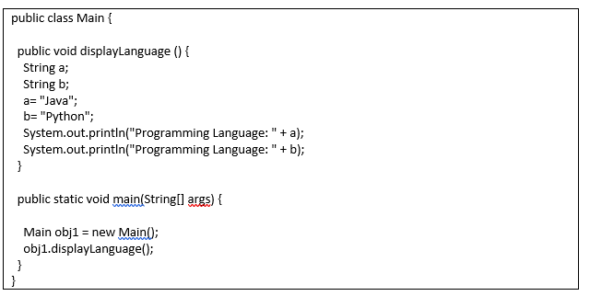

**Figure 1**

Reproduce the program in Figure 1 and use **constructor** **overloading** in this coding.

Sample output:

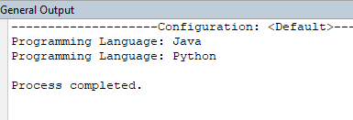

|  |
| --- |
| 1. **Source code**   **\*snip and paste your source code here. (Make sure it is snipped from your text editor/ java platform). Refer Appendix 1 for an example.** |
| 1. **Output**   **\*snip and paste your output here. (Make sure it is from your command prompt/ java platform). Refer Appendix 1 for an example.** |

**QUESTION 2**

The program in **Figure 2** is supposed to achieve the following:

1. Change the below code to code with method overloading
2. Create 3 method overloading in this program
3. The name of method overloading is **mul()**

Change the below code to three method overloading which utilise

1. 1 Method with no arguments
2. 2 Method with integer arguments ( 1 for multiplying two values, 1 for multiplying three values) that displaying below outputs:

Rewrite and define each of the calculation overloading methods so that the program will run successfully.

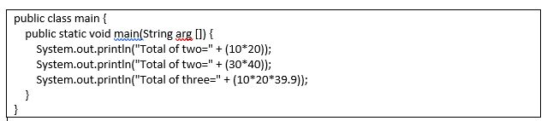

**Figure 2**

**Sample Output**

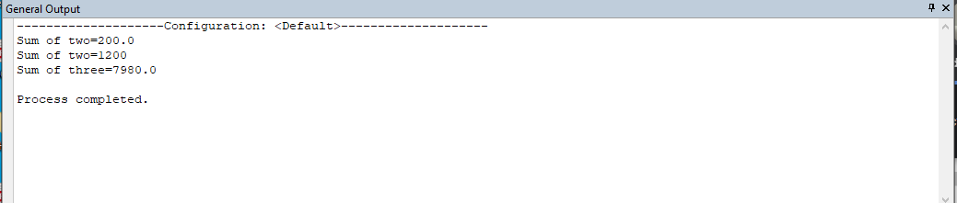

|  |
| --- |
| **A. Source code**  **\*snip and paste your source code here. (Make sure it is snipped from your text editor/ java platform). Refer Appendix 1 for an example.** |
| **B. Output**  **\*snip and paste your output here. (Make sure it is from your command prompt/ java platform). Refer Appendix 1 for an example.** |

**QUESTION 3**

Write the program that use string method

1. String **str1**=” I like to eat Apple”
2. String **str2**=”An Apple a day keeps the doctor away”

The program is required to have the following:

i) Combin*e* both string using String method

ii) Replacestr1 that contain “I” to “You” and str2 that contain “Apple” to “Durian”

iii)Calculate length each string for **str1** and **str2**

iv) Check str1 and str2 that have” *Apple”*

Sample Output:

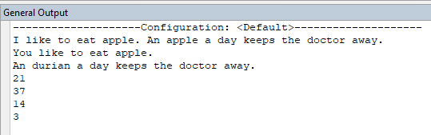

**ii**

**i**

**iii**

**iv**

|  |
| --- |
| **A. Source code**  **\*snip and paste your source code here. (Make sure it is snipped from your text editor/ java platform). Refer Appendix 1 for an example.** |
| **B. Output**  **\*snip and paste your output here. (Make sure it is from your command prompt/ java platform). Refer Appendix 1 for an example.** |

***Appendix 1***

**Example of source code:**

1. If you use Java platform to write the source code

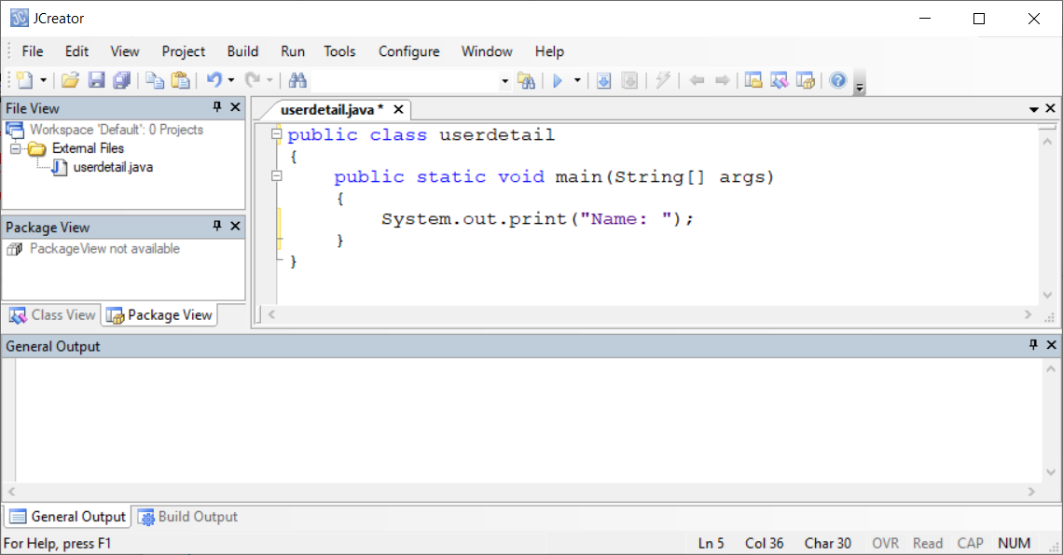

1. If you use text editor to write the source code

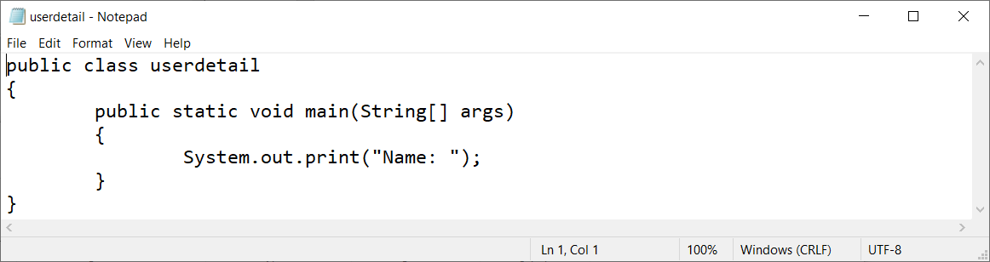

**Example of output:**

1. If you use Java platform to compile and execute

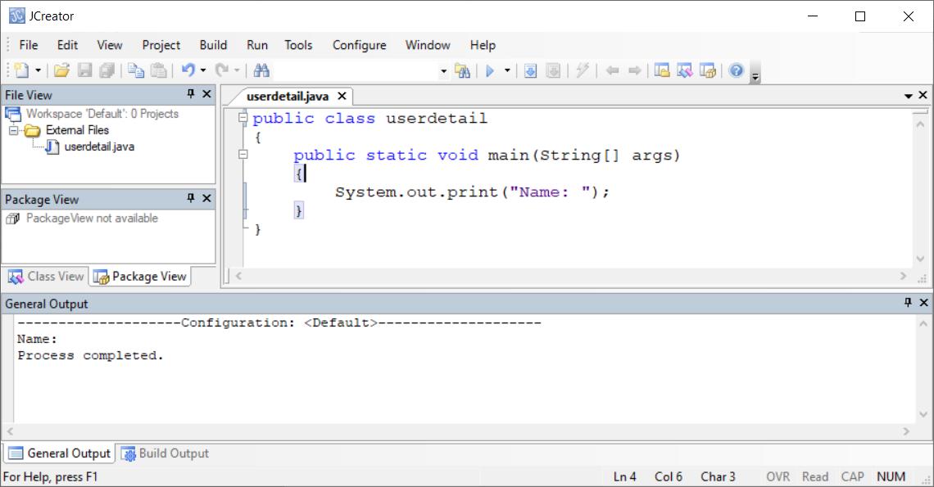

1. If you use Command Prompt to compile and execute

